Name: _______________________________________________
Yr12 Practice Questions
Calculations and Organic
Date:
Time:
Total marks available:
Total marks achieved: ______
Marcus

Questions
Q1.
(a) An impure sample of sodium hydrogencarbonate, NaHCO₃, of mass 0.227 g, was
reacted with an excess of hydrochloric acid. The volume of carbon dioxide evolved
was measured at room temperature and pressure and found to be 58.4 cm³.
The molar volume of any gas at the temperature and pressure of the experiment is
24 dm³ mol⁻¹. The molar mass of sodium hydrogencarbonate is 84 g mol⁻¹.
(i) Calculate the number of moles of carbon dioxide given off.
(1)
(ii) Calculate the mass of sodium hydrogencarbonate present in the impure sample.
(2)
(iii) Calculate the percentage purity of the sodium hydrogencarbonate. Give your
answer to two significant figures.
(2)
(b) (i) The total error in reading the gas syringe is ±0.4 cm³. Calculate the percentage
error in measuring the gas volume of 58.4 cm³.
(1)
(ii) Suggest why the carbon dioxide should not be collected over water in this
experiment.
(1)
..............................................................................................................................................
..............................................................................................................................................
(Total for question = 7 marks)

Q2.
Alkenes are unsaturated hydrocarbons. They are used in the industrial production of many organic compounds.
(a) Add structural formulae to the flowchart below to show the organic product formed in each addition reaction of 2-methylpropene.
(4)
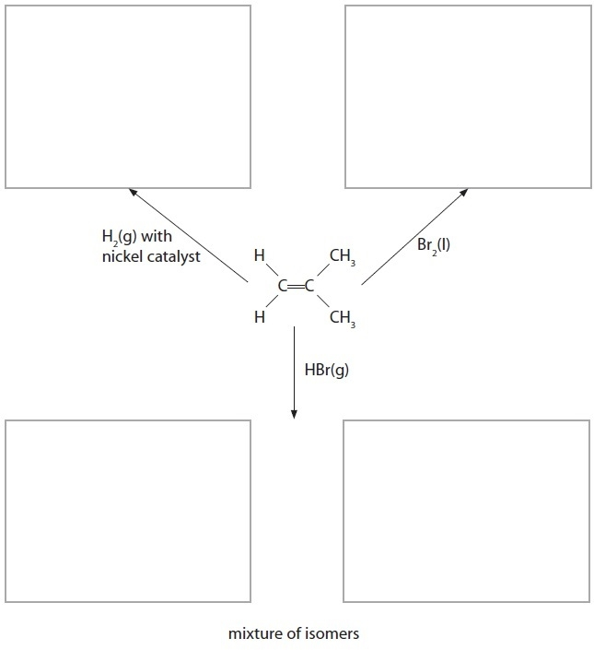
(b) Suggest a mechanism for the reaction of 2-methylpropene with bromine, Br₂(l). Include curly arrows.
(3)
(c) Ethene, C₂H₄, was prepared from ethanol, C₂H₅OH, by the following reaction
C₂H₅OH → C₂H₄ + H₂O
A chemist reacted 9.2 g of ethanol, C₂H₅OH, and obtained 4.2 g of ethene.
Calculate the percentage yield of ethene in the reaction.
(2)
(Total for Question = 9 marks)

Q3.
Alkenes are unsaturated hydrocarbons which, because of their reactivity, are important industrial starting materials. Alkenes for industrial use are obtained by cracking alkanes.
(a) Write the equation for the cracking of decane (C₁₀H₂₂) to form 1 molecule of propene as the only alkene.
(1)
(b) The carbon–carbon double bond in alkenes consists of a σ and a π bond.
(i) Explain, using diagrams, the difference between the σ and the π bond in the carbon–carbon double bond of an alkene.
(4)
Diagrams
Explanation
.............................................................................................................................................
.............................................................................................................................................
.............................................................................................................................................
.............................................................................................................................................
(ii) State the type and mechanism involved in the typical reaction of alkenes.
(1)
.............................................................................................................................................
*(iii) By considering the strength and structure of the π bond, explain why alkenes are more reactive than alkanes.
(2)
.............................................................................................................................................
.............................................................................................................................................
.............................................................................................................................................
.............................................................................................................................................
.............................................................................................................................................
(c) When propene reacts with hydrogen bromide, there are two possible products.
(i) Draw a displayed formula of each of these products and label the major product.
(2)
(ii) Give the mechanism for the reaction of propene with hydrogen bromide which forms the major product.
(3)
(iii) Explain, by referring to the mechanism, why the major product is formed.
(2)
.............................................................................................................................................
.............................................................................................................................................
.............................................................................................................................................
.............................................................................................................................................
(d) The polymer poly(propene) is manufactured from propene.
(i) Write an equation for the polymerization, drawing the displayed formula of the repeat unit of poly(propene).
(3)
(ii) UV radiation causes poly(propene) to degrade. Suggest one advantage and one disadvantage of this.
(2)
Advantage
.............................................................................................................................................
.............................................................................................................................................
Disadvantage
.............................................................................................................................................
.............................................................................................................................................
(Total for question = 20 marks)

Q4.
How many molecules are present in 16 g of oxygen gas, O₂(g)?
[Avogadro constant = 6 × 10²³ mol⁻¹]
A 96 × 10²³
B 12 × 10²³
C 6 × 10²³
D 3 × 10²³
(Total for question = 1 mark)

Q5.
Calculate the mass of calcium hydroxide, Ca(OH)₂, present in 100 cm³ of a 0.100 mol dm⁻³ solution.
[Assume the molar mass of Ca(OH)₂ is 74.0 g mol⁻¹.]
A 0.570 g
B 0.740 g
C 1.85 g
D 3.70 g
(Total for question = 1 mark)

Q6.
Sodium burns in oxygen to give a pale yellow solid X.
(a) (i) 1.73 g of sodium reacts with 1.20 g of oxygen.
Calculate the empirical formula of X.
(2)
(ii) The molar mass of X is 78 g mol⁻¹. Give the molecular formula of X.
(1)
.............................................................................................................................................
(iii) Write the equation, including state symbols, for the reaction of sodium with oxygen to produce X.
(2)
(iv) Calculate the volume of oxygen in dm³ (at room temperature and pressure) which reacts with 1.73 g of sodium. (The molar volume of any gas at room temperature and pressure is 24 dm³ mol⁻¹.)
(2)
(v) Calculate the number of oxygen molecules that react with 1.73 g of sodium. (The Avogadro constant = 6.02 × 10²³ mol⁻¹.)
(1)
(b) If sodium is burnt in air, compound X is not the only product. Suggest why this is so.
(1)
.............................................................................................................................................
.............................................................................................................................................
.............................................................................................................................................
(Total for question = 9 marks)

Mark Scheme
Q1.

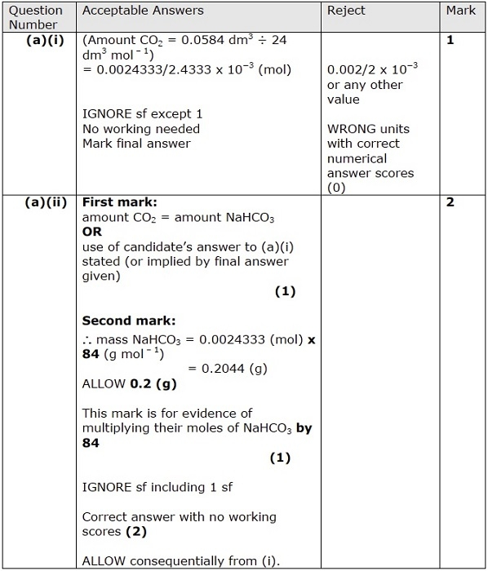
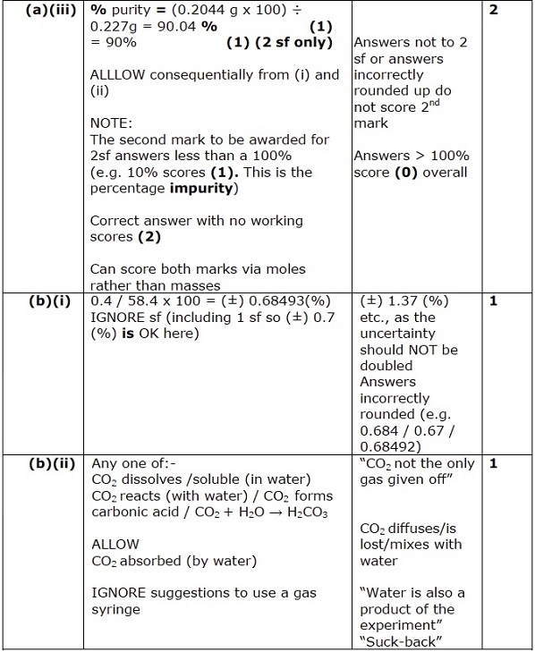

Q2.
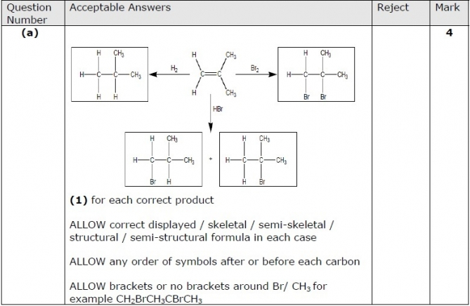
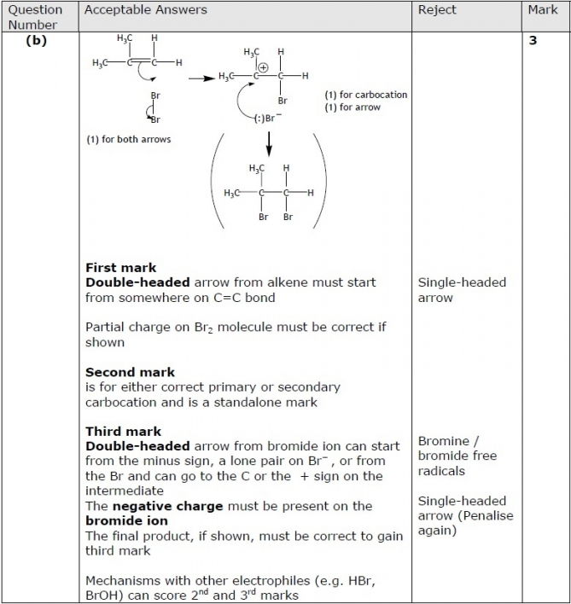
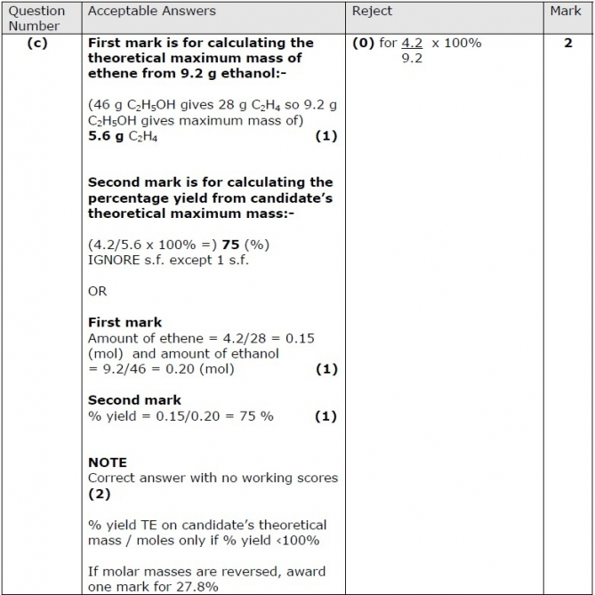

Q3.

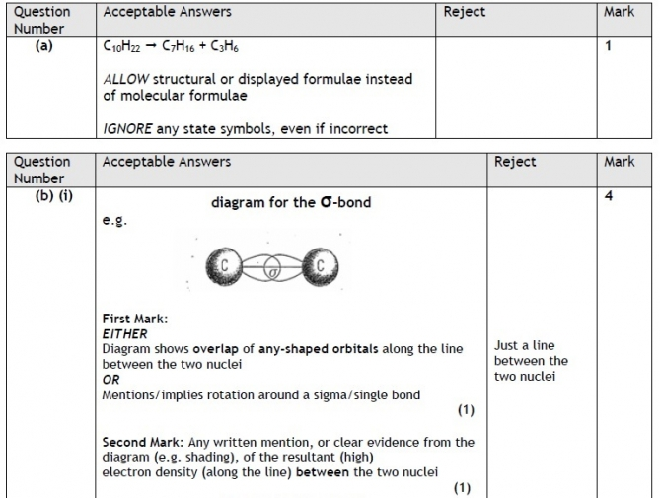
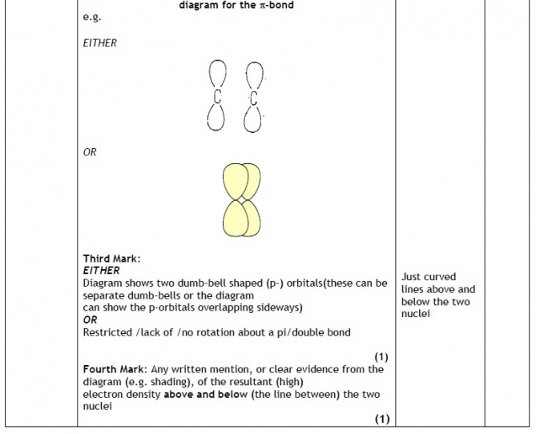
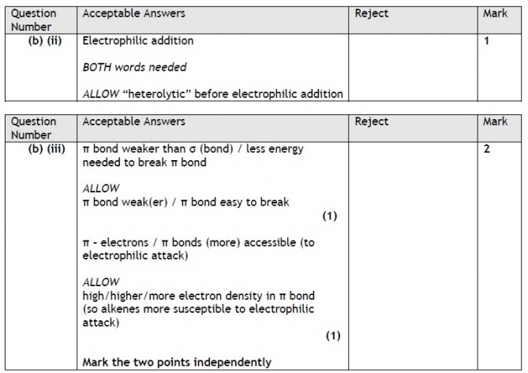
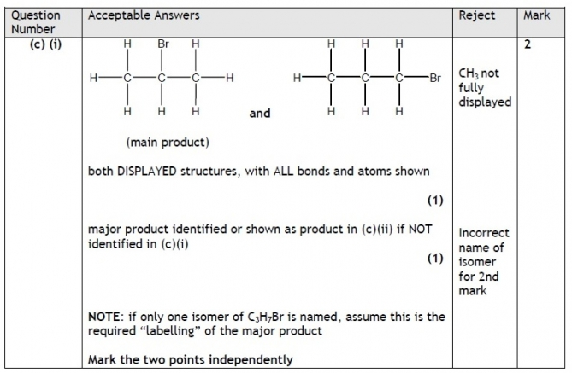
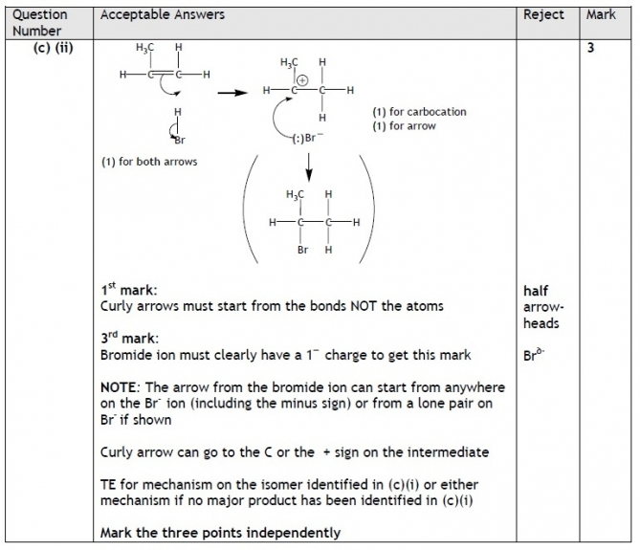
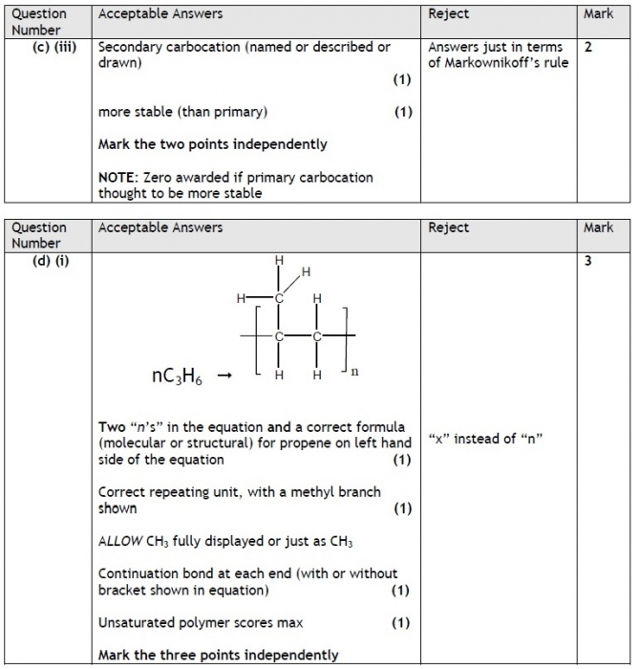
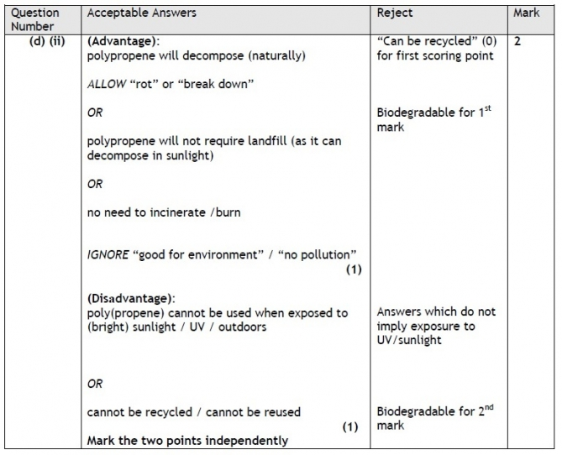

Q4.

Q5.

Q6.

